A000-US-SD-Missouri River-Clovis and Midland Projectile Points-ca 11,000 BCE

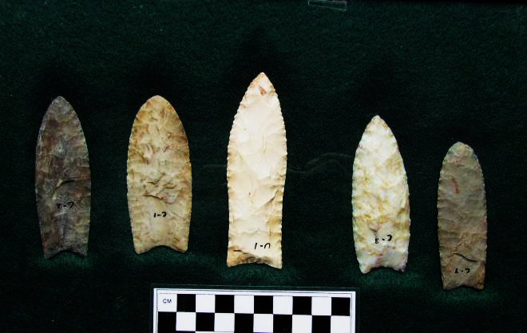

Figs. 1-5. SD-Missouri River-Clovis and Midland Projectile Points-ca 11,000 BCE

**Case no.: 12**

**Accession Numbers:**

**Formal Label:** SD-Missouri River-Clovis and Midland Projectile Points-ca 11,000 BCE

**Display Description:**

**LC Classification:**

**Date or Time Horizon:**

**Geographical Area:**

**Map:**

**GPS coordinates:**

**Cultural Affiliation:**

**Media:**

**Dimensions:**

**Weight:**

**Condition:**

**Provenance:**

**Discussion:**

**References:**